Eg: If_Else_Eg19
// go through the code

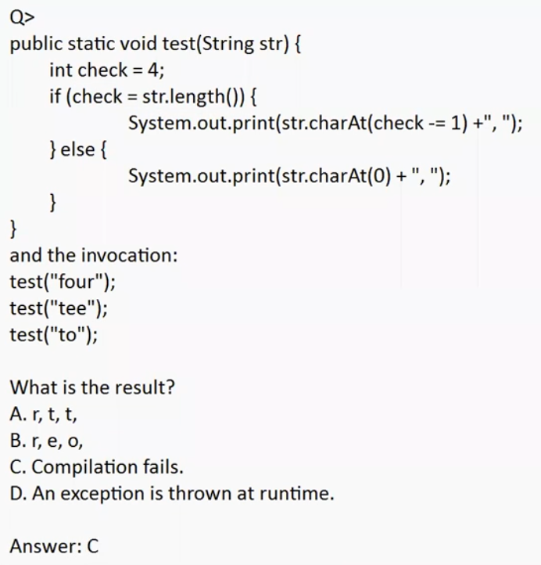

❓ What is the Question Asking?
What will be the result?
Options:
- A. r, t, t
- B. r, e, o
- C. Compilation fails
- D. Runtime exception
Correct answer: C
Now let’s understand WHY compilation fails.

🔥 CORE PROBLEM LINE (Very Important)
if (check = str.length())

🚫 This is NOT a comparison
- = → assignment operator
- == → comparison operator
So this line means:
Assign str.length() to check

🔍 Step-by-Step What Java Sees
1️⃣ str.length() returns an int
- "four" → 4
- "tee" → 3
- "to" → 2
2️⃣ Assignment happens:
check = str.length(); // check becomes 4 / 3 / 2
3️⃣ The value of an assignment expression is the assigned value itself
So this expression returns an int, not a boolean.

🚨 Why Compilation Fails

Java rule (VERY IMPORTANT):
if (condition) // condition MUST be boolean
But here:
if (check = str.length()) // ❌ returns int
Java does NOT allow int to boolean conversion.
❌ This is illegal in Java:
if (1) { }
if (0) { }
Unlike C/C++, Java is strictly type-safe.

🛑 Compile-Time Error Message (Conceptually)
incompatible types: int cannot be converted to boolean
So the program never compiles, and:
- No method calls run
- No output is produced
- No runtime exception occurs

✅ Why Option C Is Correct
Option | Reason
A | Code never runs
B | Code never runs
D | Runtime exception needs successful compilation
✅ C | Compilation fails before execution

🧠 Key Exam Rule (WRITE THIS)
In Java, the condition of an if statement must return boolean.
Assignment (=) returns a value, not a boolean, so it cannot be used inside if.

Eg: Operators
// go through the program

Eg: Operators_Eg2
// go through the code

Eg: Operators_Eg3
// go through the code

Eg: Operators_Eg4
// go through the code

Eg: Operator_Eg5
// go through the program

Eg: Operator_Eg6
// go through the program

Eg: Operator_Eg7
// go through the code

